

Mathematics Department |  | 
Course: A2MAA
Topic Title: Test 2
Student Name:_____________________________________ | Date: _______________2016
Special Instructions: Formula Sheet, 1 page of double sided A4 notes and calculators allowed. | Time Allowed: 50 minutes
 | Marks: / 40

Question 1 (4 marks)

Use the triangle below to obtain the fractions for the trigonometric ratios given.

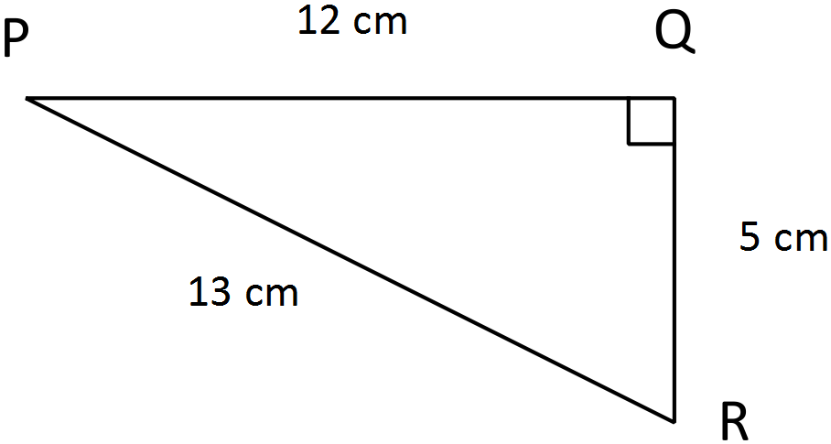
- sin P = _________

- sin R = _________

- cos R = ________

- tan P = ________

Question 2 (2 marks)

Calculate the length of the missing side.

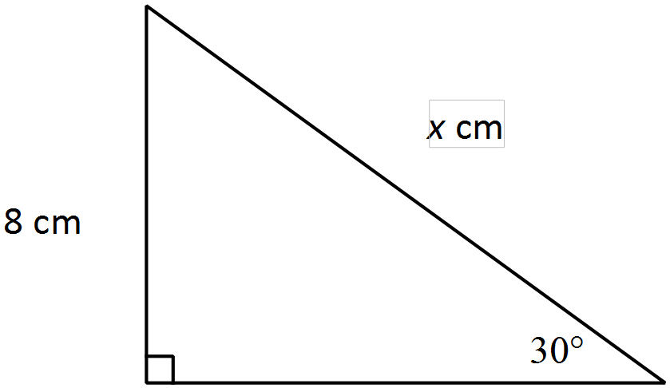

Question 3 (2 marks)

Calculate the bearing of A from B in the following two scenarios.

- 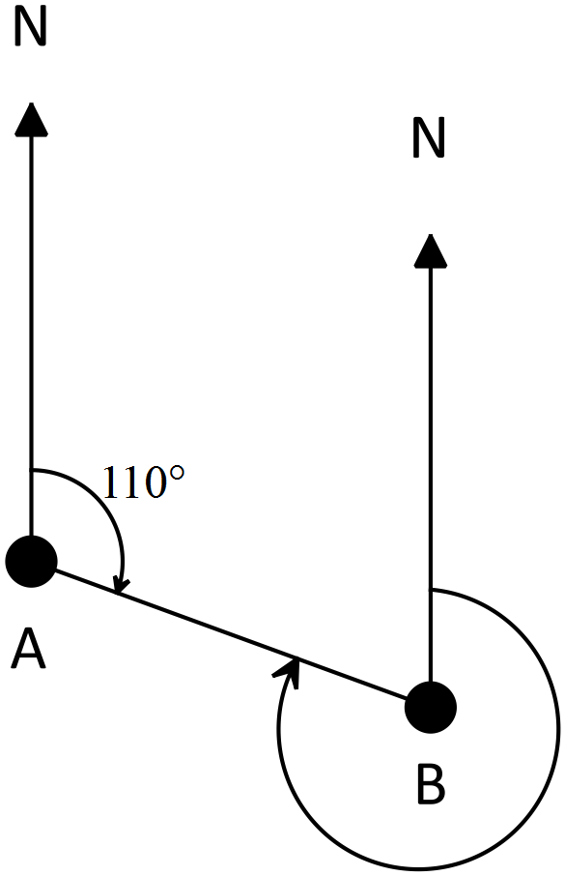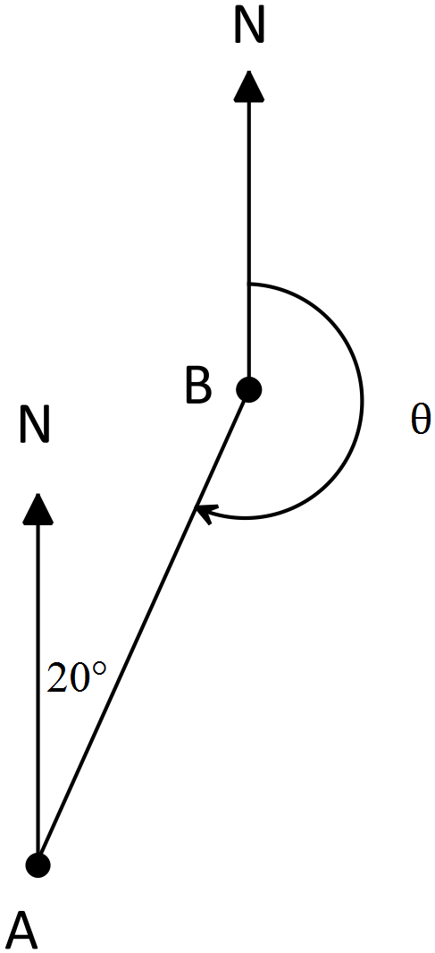b)

Question 4 (2 marks)

Calculate the area of the triangle below.

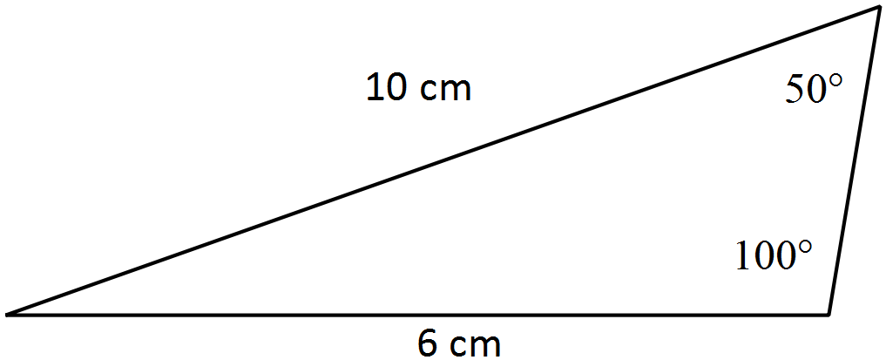

Question 5 (4 marks)

Find the value of $x$ in each of the following. (diagrams are not to scale)

- (2 marks)
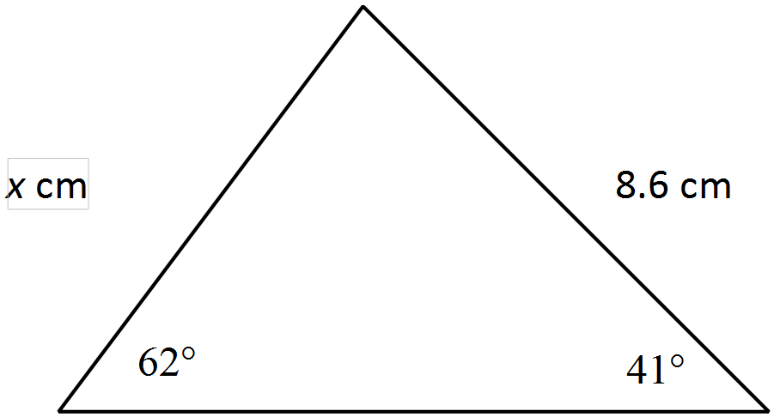

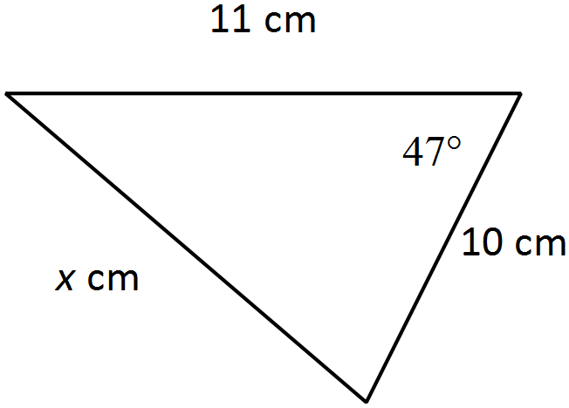
b) (2 marks)

Question 6 (3 marks)
A ladder leans against a wall inclined at an angle 27° to the horizontal. If the ladder reaches 7.5m up the wall, what is the length of the ladder?

Question 7 (3 marks)

A triangle has an area of 767.69 cm². The lengths of two of the sides of the triangle are 43.1cm and 38.7cm. Find the size of the angle between these two sides.

Question 8 (6 marks)

From the top of the cliff, ship A is observed at an angle of depression of 15°, 35m from the base of the cliff. At the same time ship B is observed 12m from ship A as shown in the diagram below.

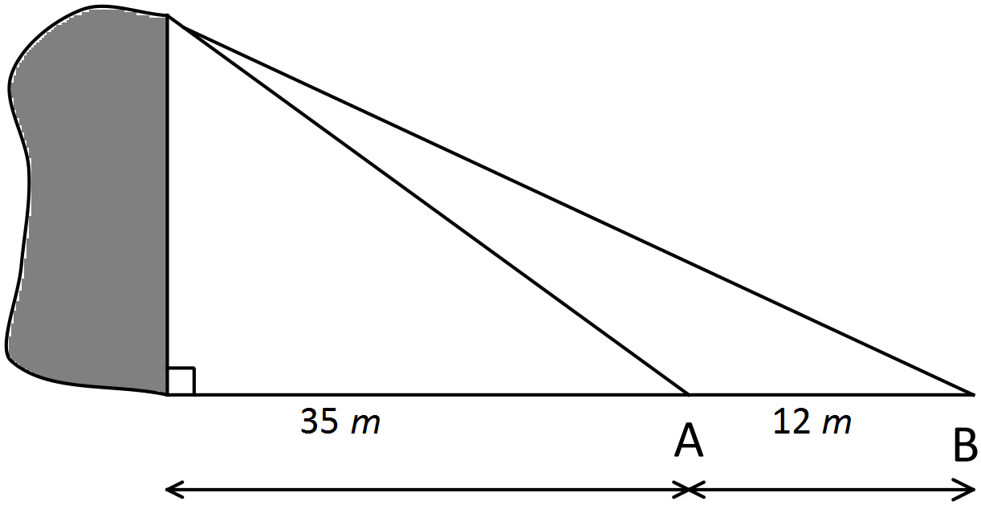

Determine:
- The height of the cliff (4 marks)

- The angle of elevation from ship B to the top of the cliff (2 marks)

Question 9. (4 marks)

Consider the triangle below.
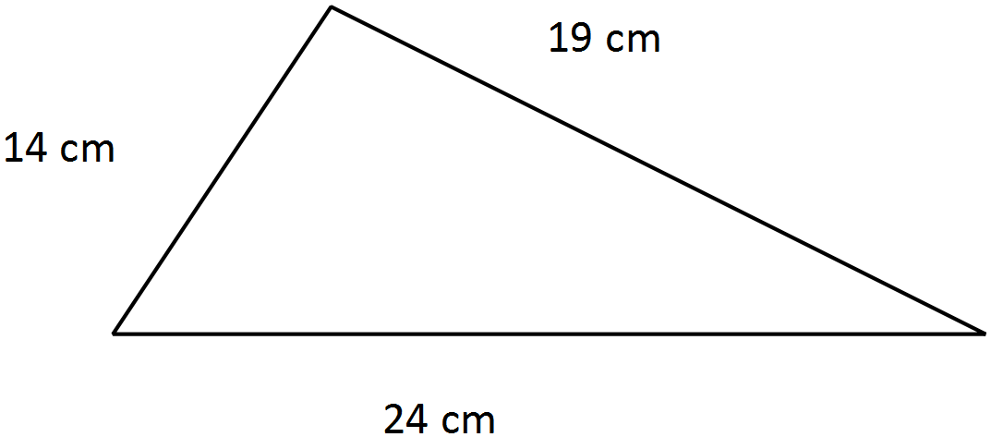

Use Heron’s formula to calculate the area of this triangle.

Question 10 (10 marks)
Ship A leaves port P travelling 120km west. Ship B leaves port on a bearing of 215° travelling 120km.

Find:
- Draw a diagram to show this. (2 marks)

- the distance between the two ships (2 marks)

- the bearing of ship A from ship B (4 marks)

- the bearing of ship B from ship A (2 marks)

